# CS 340 README

*Use this template to complete your README file. When completing the template, keep the headings as they are so that your document has a clear organization. Remove the italicized prompt text after you have completed each section for a polished final document.*

## About the Project/Project Title

*The purpose of this project is for users to implement the fundamental operations of CRUD in python. This will quickly create, read, update, and remove details on an animal within a singular stored dataset.*

## Motivation

*This project exists for users to create and read information in a certain dataset when processing a query in the Mongo database easily and conveniently*

## Getting Started

*To get started the user would enter their Apporto environment and import the data sets into the MongoDB using the mongoimport command.*

*After importing the datasets, you will create users to a specified database and establish permissions for the users.*

*Start a new terminal and login to the database with the user credentials. After importing and creating user accounts you should then test authenticating your user account to access the dataset.*

## Installation

*The tools needed to use the software were the mongoDB terminal command line and Jupyter Notebook. The library used was Pymongo and object ID.*

## Usage

### Code Example

An animal_shelter.py file was created to run the create and read commands on the python file.

Code to initialize connection.

Code to create data and insert it into the collection database.

Code to read data within the database.

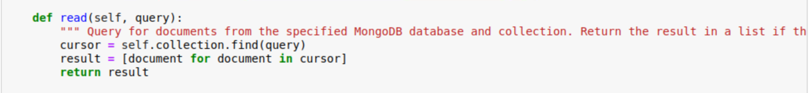

Code to update specified data within the database.

Code to delete specified data within the database.

### Tests

The testing_app was executed within Jupyter Notebook by importing the Python function and when running the code this would test creating and reading some sample data from the database.

### Screenshots

Example Usage of CRUD

*Testing Results.*

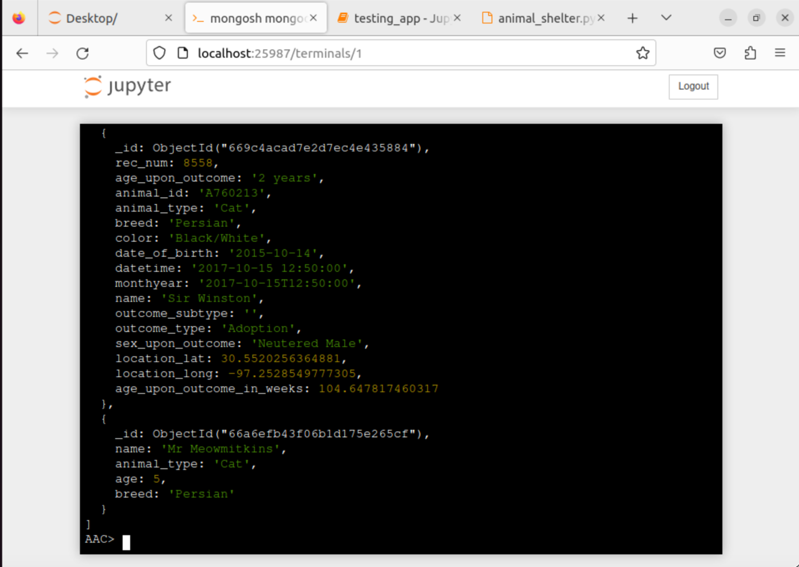

## Contact

Your name: Victoria Johnson